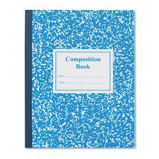
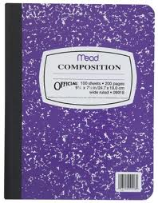
JJournal writing Rubric
Student’s Name ________________________________

SKILLS | Expectation | 1 | 2 | 3 | 4
vocabulary | Does the student use varied and complex vocabulary? | Student needs to use more variety and complexity in their vocabulary use. | Sometimes uses variety and complexity in their vocabulary use. | Student uses a good variety of vocabulary and this is complex. | Student uses complex and varied vocabulary consistently.
Elaboration | Does the student add details or give examples? | Student needs to work on including details and examples. | Sometimes student gives details or examples. | Student always gives details or examples. | Student gives many details and uses adjectives.
Structure | Are the student’s entries written in sequence with a beginning, middle and end? | Student needs to work on sequencing his/her entries. | Student’s entries are sometimes in sequence. | Student’s entries are always in sequence. | Student’s entries are always in sequence and he/she uses introductory and concluding sentences.
Conventions | Does the student write in sentences, use correct capitalization and spelling? | Student needs to work on writing in sentences, using capitals and correct spelling.  (Does 1 out of 3) | Sometimes student writes in sentences, uses correct capitalization and spelling. (Does 2 out of 3) | Student always writes in sentences, uses correct capitalization and spelling. | Student does all that’s expected AND uses different kinds of punctuation.  (? and !)
Length | Are the student’s entries at least one page? | Student needs to work on making his/her entries longer. | Student’s entries are longer than 4 sentences. | Student’s entries are always one page. | Student’s entries are longer than one page.

